Cirrus AP Trax Payment Recon Extract

Modified BIP for Cirrus AP Trax Payment Recon Extract

**BIP for Country/Region:** GRID

***Developer Name and SSO:*** *<Chundi, Venkata Ramachandra Karthik & 223074237>*

***Delivered Date:*** *REL-084 Emergency Release*

***Project Name:*** Fusion Clone and Convey

***Project Manager:*** *<Kilaru, Seshagiri & 210073716>*

***Team Name:***Fusion Clone and Convey

***Technical Team Lead:*** *<Chundi, Venkata Ramachandra Karthik & 223074237>*

***Functional Team Lead:*** *<Kilaru, Seshagiri & 210073716>*

***AHA Request id:*** *NA*

***Functional Owner****: <Kilaru, Seshagiri & 210073716>*

***Functional Consultant:*** *<Kilaru, Seshagiri & 210073716>*

***Peer Reviewed by:*** *<Dsouza, Richard & 503270420>*

***Peer Review Comments:*** *Fixed*

***Peer Review Passed*:** Yes

**If Peer Review is not passed then Reason:** N/A

**Global Component (applicable to GED/All countries):** No

Sends file to GXS?: No

***Approval History:***

***Is Tested in UAT****: Yes/No/NA: NA*

*Yes ,Attach UAT Sign Off :NA*

***Is it an Integration:*** *No*

*Yes,Attach Third Party Sign Off :No*

***Is TRB approved?*** *No*

*Yes ,Attach TRB Sign Off :Attached*

***Is new job scheduling required in Automic tool***: No

If Yes then Have you informed Fovenyi, Zsolt (GE Corporate) [zsolt.fovenyi@ge.com](mailto:zsolt.fovenyi@ge.com): N/A

***Is any parameter update/addition done to scheduled job in Automic tool***:No

If Yes then Have you informed Fovenyi, Zsolt (GE Corporate) <[zsolt.fovenyi@ge.com](mailto:zsolt.fovenyi@ge.com)> / Park, Jonghun (GE Corporate) <jonghun.park@ge.com> : N/A

***Component #***

***Brief Description:* (Release Number – 084 Emergency Release)**

updated bursting logic for file delivery from Fusion to other systems no longer involves the utilization of the profile option.

***SVN Code Path:***

SVN\branches\Releases\ QA Completed\ REL-084-Jan-2024\Emergency Release \Cirrus\Code

***SVN Document Path:***

SVN\branches\Releases\QA COMPLETED\ REL-084-Jan-2024\Emergency Release \Cirrus\Documentation

***SVN Migration Document Path:***

SVN\branches\Releases\QA COMPLETED\ REL-084-Jan-2024\Emergency Release \Cirrus\Documentation\Migration Documents

***Attachments*:** *Attach the scripts, MD documentation, Implementation instructions and Sign off etc., which are required to migrate.*

*Below is the list of components that are placed in SVN and needs to migrate in sequential manner:*

***Code Path:***

SVN\branches\Releases\QA COMPLETED\ REL-084-Jan-2024\Emergency Release \Cirrus\Code

|  |  |
| --- | --- |
| 1. Cirrus_AP_Trax_Payment_Recon_Extract_DM.xdmz   *Below is the list of documents’ that are placed in SVN and used to migrate*  ***Document Path:***  SVN\branches\Releases\QA COMPLETED\ REL-084-Jan-2024\Emergency Release \Cirrus\Documentation   * MD 120 Cirrus AP Trax Payment Recon Extract.docx * MD 70 Cirrus AP Trax Payment Recon Extract.docx |  |
|  |  |

## Business requirements

The list of the key business requirement is as follows: -

|  |  |
| --- | --- |
| Requirement ID | Requirement Description |
|  | The requirement is to Extract the payment file of TRAX to the server. |
|  |  |

**Migration Instructions**

**(**1. Cirrus_AP_Trax_Payment_Recon_Extract_DM.xdmz**)**

Click on Navigator 🡪 Report and Analytics

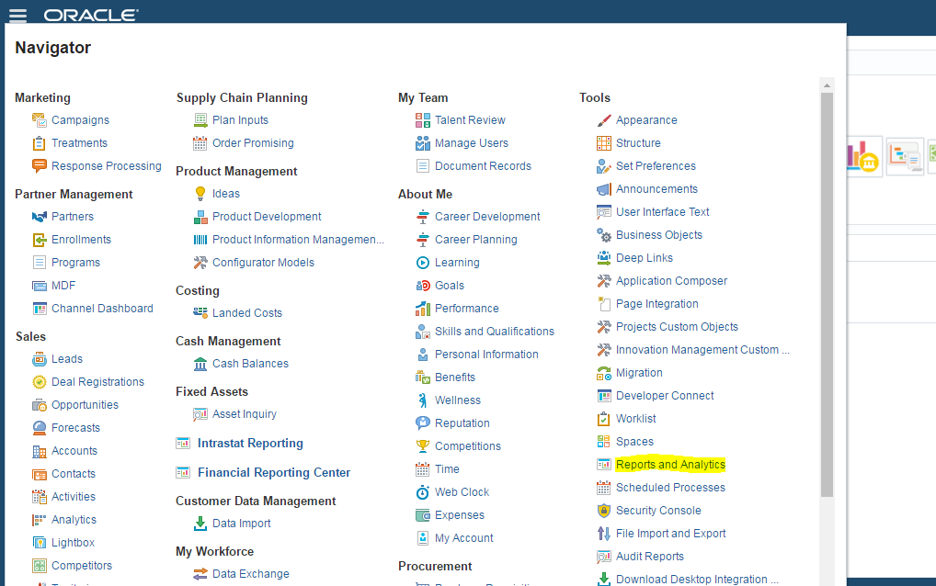

1. Click on Browse Catalog

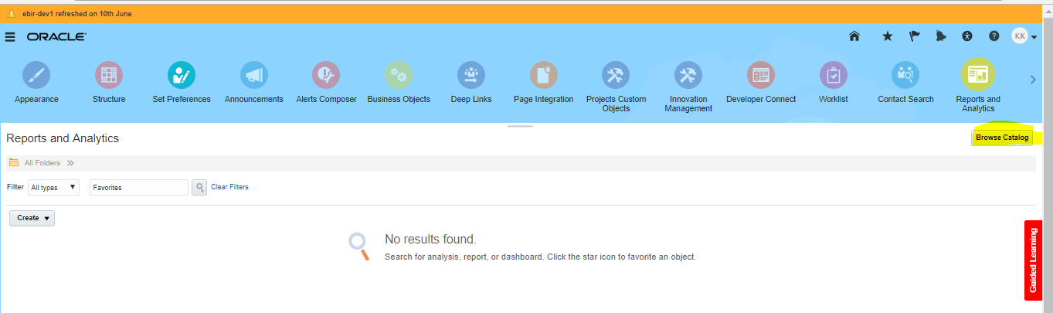

1. Replace “analytics/saw.dll?catalog” in the URL with xmlpserver and press enter. Click on Catalog

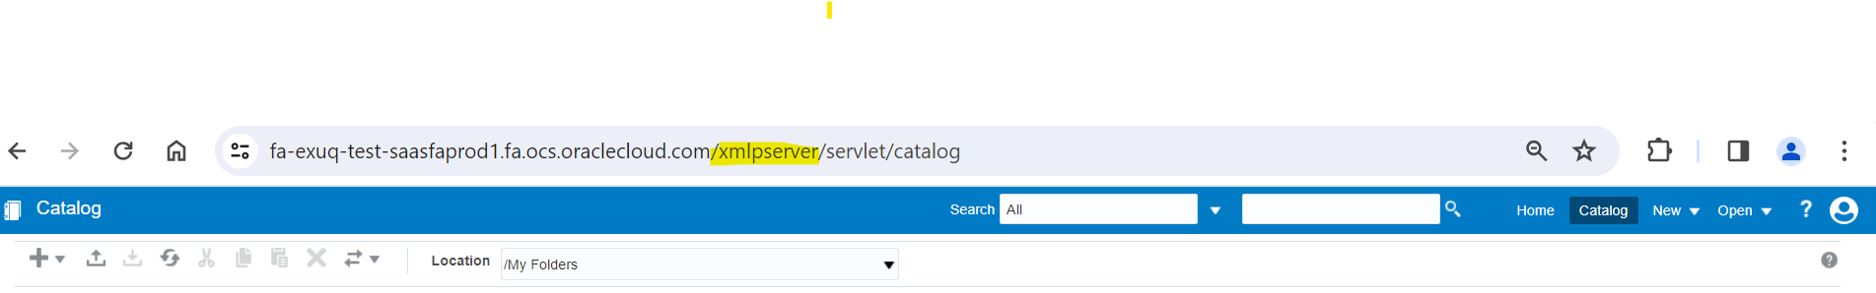

2) Navigate to Custom/Financials/Payments/Data Model

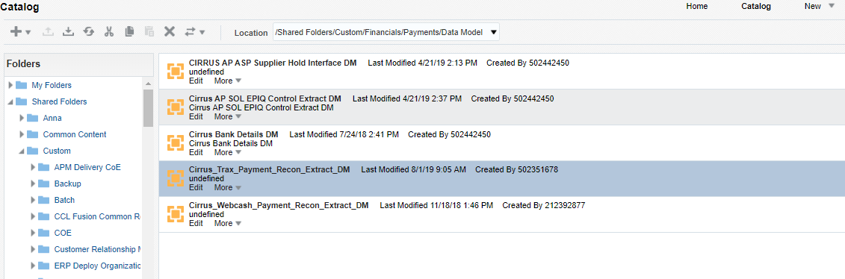

Take the backup of “Cirrus_AP_Trax_Payment_Recon_Extract_DM.xdmz” existing code from Prod

3)Upload ‘Cirrus_AP_Trax_Payment_Recon_Extract_DM.xdmz ‘ and click on ‘Upload’.

4)Window will show the message “Uploading” Please wait for the process to complete.

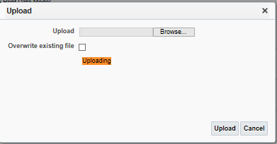

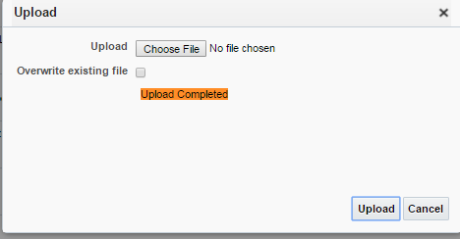

**Evaluate the Migrated Objects:**

Please ensure the migrated object is valid in below path

Shared Folders 🡪 Custom🡪 Financials 🡪 Payments 🡪 Data Models

1. Cirrus_AP_Trax_Payment_Recon_Extract_DM.xdmz